Upgrade binary mysql version in docker

Skenario :
- Install mysql 5.7
- Create database schema
- Shutdown
- Upgrade to latest version
- Check database schema and version
- Done...

Pre requiretements :
- Check your target binary version in docker hub https://hub.docker.com/
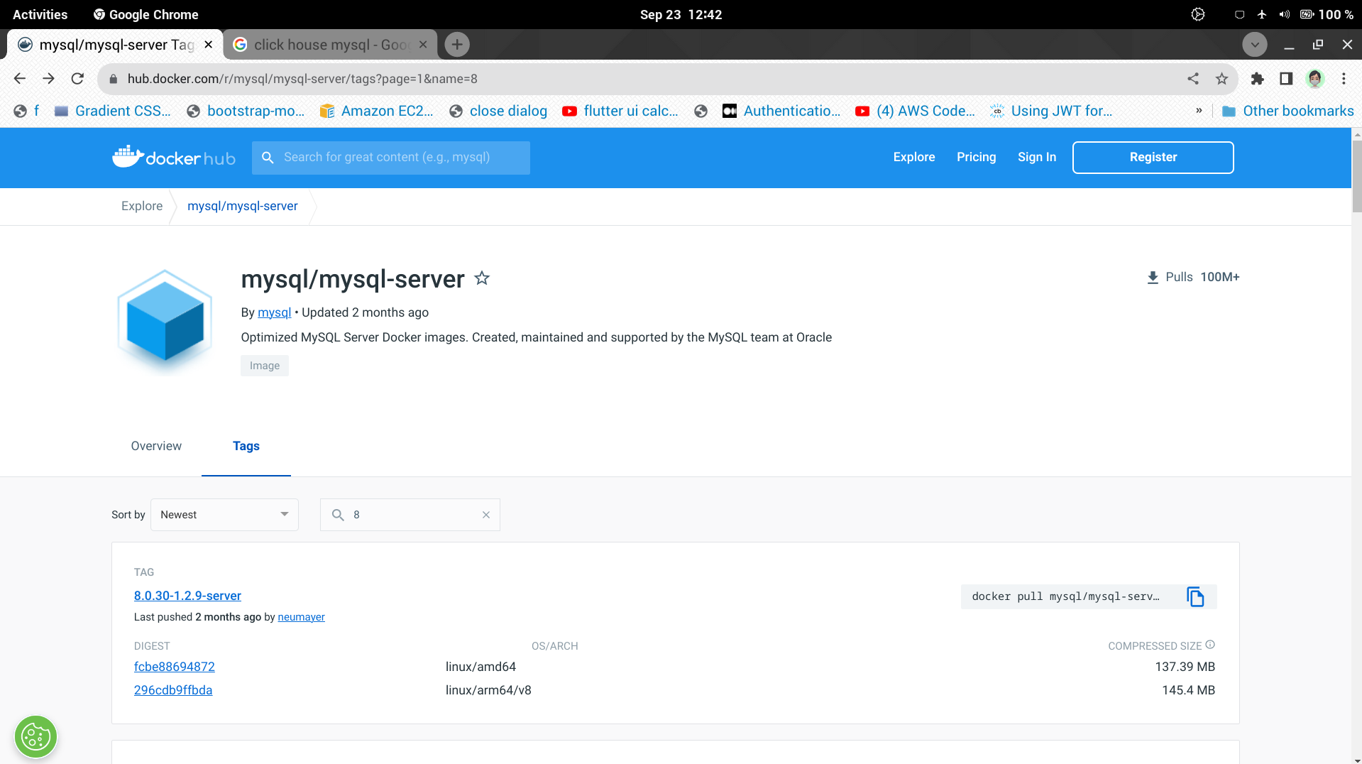
Action :

- Adjust docker-compose.yml file to image 5.7 version
- Running up a docker container
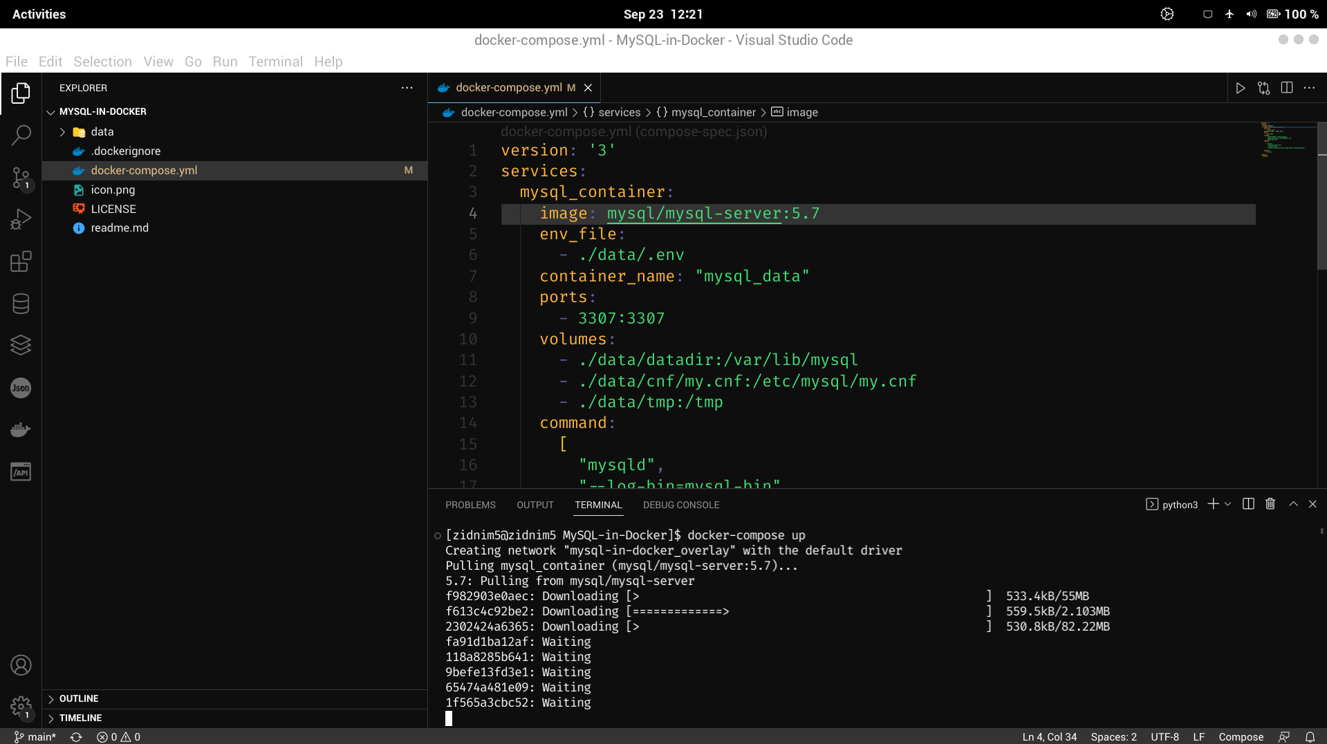
- Show database, version & shutdown it
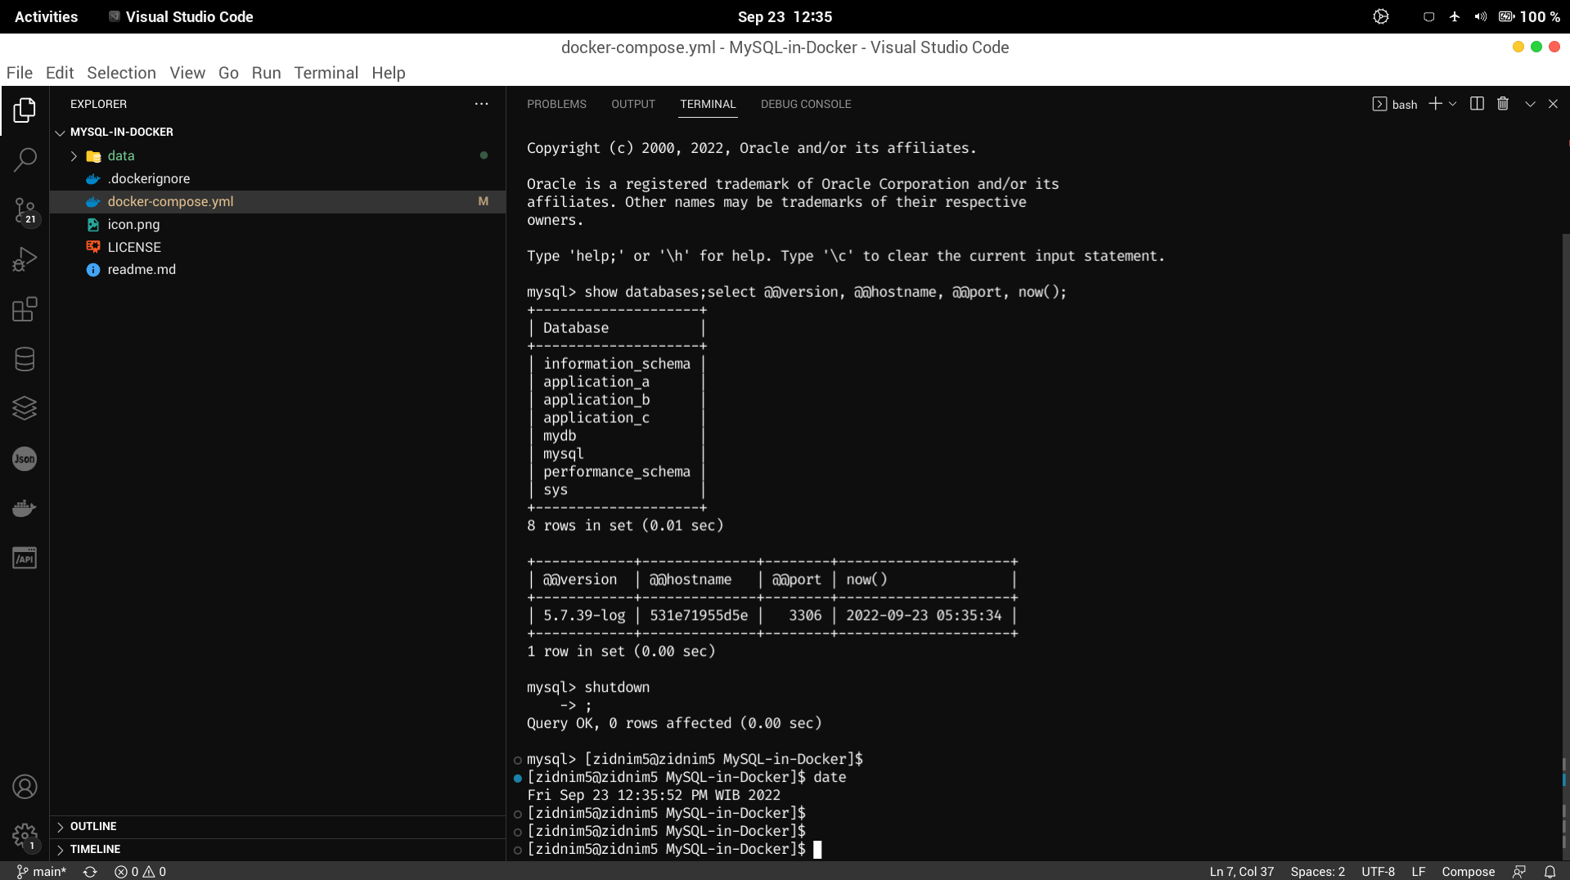

- Adjust docker-compose.yml to image latest version
- Running up a docker container
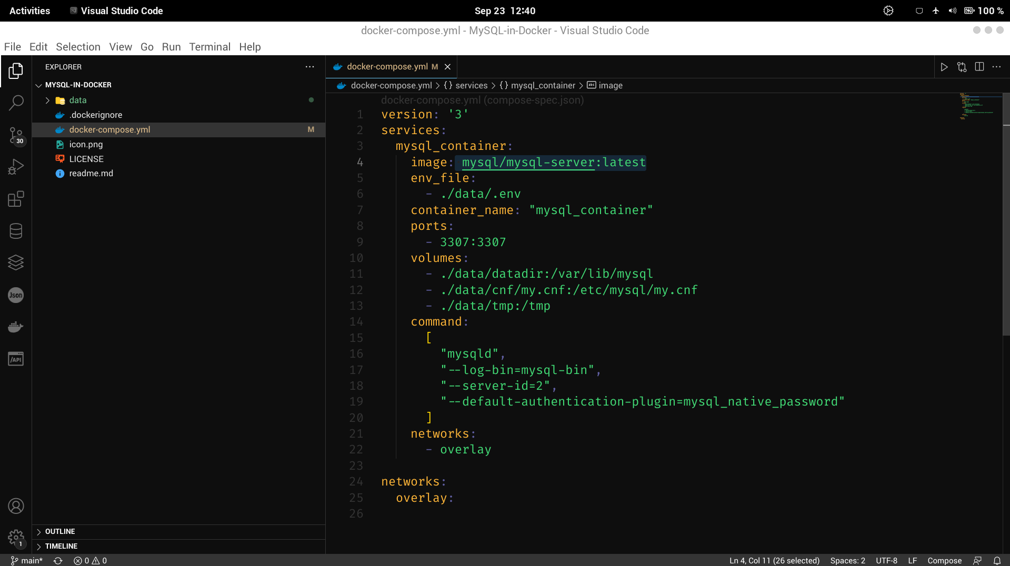
- Check current version & data with the old version data
